Name:

3.3 Nutrition | Learning Objectives  At the end of this sub section students should be able to:
3.3.3 Nutrition in the Human | - Define the following terms Heterotrophic nutrition, Autotrophic nutrition, Herbivore, Carnivore, Omnivore  - Explain why organisms need to digest food  - Explain why organisms need a digestive system  - Define Ingestion, Digestion, Absorption, Egestion
3.3.4 Human Digestive System | - Label a diagram of the human alimentary canal and its associated glands  - Give the function(s) in digestion of each part of the alimentary canal including the associated glands  - Define Peristalsis  - Explain Dental Formula  - Write out the Human dental formula  - Give the function of incisors, canines, pre molars and molars  - Describe how food is mechanically broken down by (a) Teeth, (b) Contractions of the stomach wall, (c) Peristalsis  - Explain the role of Bile Salts in Chemical digestion  - Name one Amylase enzyme and give its (1) Role in chemical digestion (2) Production Site (3) pH at the site of action (4) Products  - Name one Protease enzyme and give its (1) Role in chemical digestion (2) Production Site (3) pH at the site of action (4) Products  - Name one Lipase enzyme and give its (1) Role in chemical digestion (2) Production Site (3) pH at the site of action (4) Products  - Describe how the structure of the small intestine is suited to its function in digestion of food (infoldings of wall to increase surface area, enzyme secreting glands in the wall, liver and pancreas secrete into duodenum  - Describe how the structure of the small intestine is suited to its function in absorption of digested food (villi, rich blood supply, thin walls)  - Outline the role of the large intestine in (1) Reabsorbing water (2) Eliminating faeces  - Give two functions of Symbiotic bacteria in the digestive tract  - Outline the benefits of dietary fibre  - Label a diagram of a single villus and give the functions of the labelled parts
3.3.5 Blood Transport of Nutrients | - Describe the composition of blood fluid as a transport system of nutrients in the human body.  - Describe the absorption of Fatty acids and Glycerol into the lacteals of the villi.  - Describe the absorption of Glucose, Amino acids, Vitamins and Minerals into the blood vessels of the villi.  - Name the three blood vessels associated with the liver.  - Describe the transfer of absorbed nutrients through the hepatic portal vein to the liver.  - Describe the functions of the liver 15/12/2013  - Explain the need to transport nutrients to all nutrient-requiring cells of the body.  - Explain the need to transport waste products to the kidney for excretion.
3.3.6 Balanced Human Diet | - Learn the five main food groups  - Define balanced diet  - Learn to draw a human food pyramid  - State the recommended average daily portions of each of the main food groups in the diet of an average adult  - Learn two general approaches to diet that can help a person to have a balanced diet  - Understand how age , gender and activity level can affect the dietary needs

Nutrition is the process by which an organism obtains and uses its food.

Need to digest food for:
- Energy source
- Growth
- Formation of new substances
- Repair
- Reproduction – important for fertility and growth of baby
- Defence – by increasing number of defence cells and antibodies

Need for a digestive system

Most animals (not sponges) have a digestive system. This means that food is only processed once, before being transported to all cells of the body.

Digestion is necessary because the food we eat is too big to pass directly into the bloodstream. Otherwise our immune system would recognise these structures as being foreign and it would get rid of them.

A digestive system allows the materials needed to process the food to be localised in a single place e.g. teeth in mouth, acid in stomach. It also prevents each cell having to contain a full range of all the digestive enzymes.

Types of nutrition:
- Autotrophs (producers) make their own food. Most are photosynthetic e.g. green plants and some are chemosynthetic e.g. purple sulfur bacteria.

- Heterotrophs (consumers) cannot make their own food- they take in ready-made food.
Depending on what they eat they can be categorised as follows:
- Herbivore - eat plants only e.g. rabbits.
- Carnivore - eat animals only e.g. fox
- Omnivore - eat plants & animals e.g. hedgehog and humans

If the organism gets its food from a live source it is called a parasite e.g. disease-causing bacteria and potato blight fungus. Ectoparasites e.g. fleas feed on a living host and endoparasites e.g. liverflukes feed in a living host and do harm.
If the food source is dead the organism is called a saprophyte e.g. bread mould fungus. Saprophytes obtain their food in solution. Digestive enzymes are released onto the food and digestion takes place externally. The digested products are then absorbed into the organism. This method is primitive and, because of the waiting involved, does not suit more advanced organisms under threat from predators.

Stages of human nutrition:
- Ingestion - taking in of food – mouth
- Digestion - breaking up of food into smaller soluble pieces – mouth, stomach, small intestine
- Absorption - transfer of food from alimentary canal (stomach/intestines) into bloodstream and lymphatic system for distribution.
- Egestion - getting rid of undigested food - anus.

Diagram - Human Alimentary Canal (& associated glands – salivary glands, liver and pancreas)

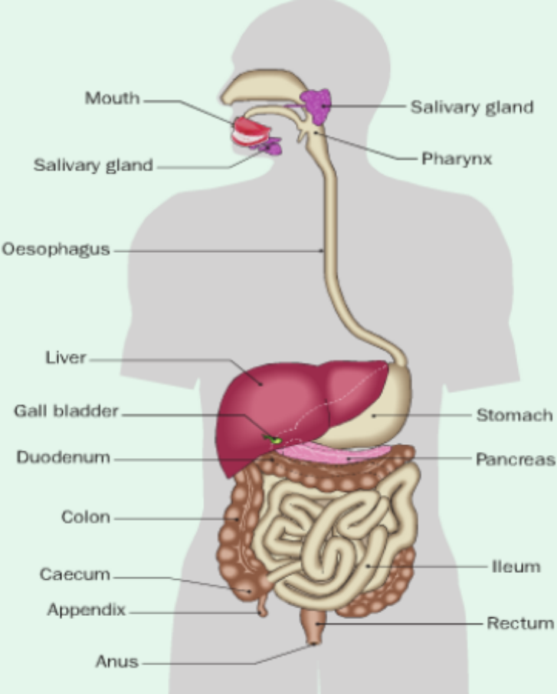

Mouth
Physical digestion by teeth
Chewing reduces the food to smaller pieces which increases the surface area for enzymes to work on. Using teeth and tongue the food is formed into a bolus ready for swallowing.
Epiglottis stops food entering trachea.

Types of teeth:
Incisor = sharp, chisel-shaped for cutting/biting
Canine (‘eye-tooth’) = long, pointed fangs for gripping and tearing
Molars & Premolars = rounded tops for grinding & crushing
The diet of an animal will determine what type of teeth it has.
Human dental formula =
2 (I 2 C 1 PM 2 M 3 ) (side view: top )
2 1 2 3 bottom
(Permanent total = 32. Milk/deciduous/child set= 20, has no molars)
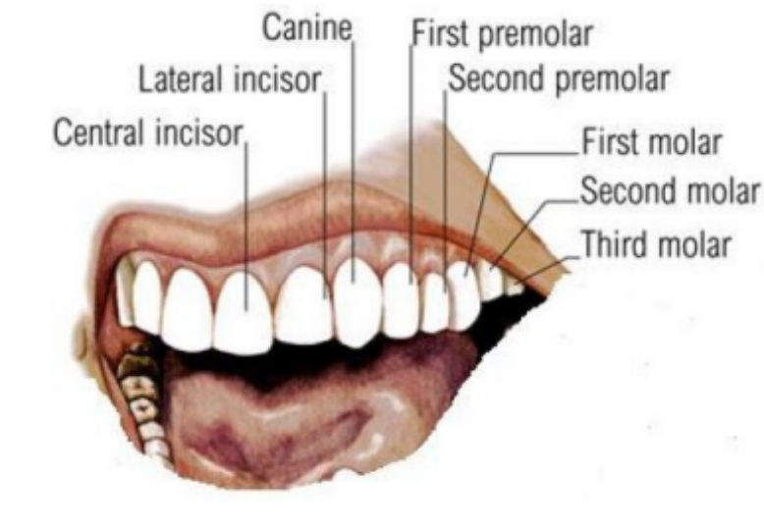
Dental disease
Causes:
Teeth can be damaged by certain types of foods or by neglect.
Tooth decay – Bacteria in plaque feed on food stuck to teeth and produce acid, which dissolves the enamel. Decay can spread through the dentine and pulp cavity. Infection of the pulp can cause an abcess (inflammation) of the gum.
Periodontal disease – plaque lodging between teeth and gums may cause gingivitis (inflammation), around the roots. Periodontal fibres become destroyed as the gums recede, resulting in the teeth becoming loose and possibly being lost.
Prevention:
Regular tooth brushing
Reduce sugars
Not eating between meals
Eating high-fibre foods
Chewing strengthens gums and teeth
Regular dental check-ups

Chemical digestion by salivary amylase, produced by salivary glands. Saliva consists of water, salts, mucin, amylase and lysozyme. Mucin and water help to soften and dissolve food so that we can taste and swallow it. Lysozyme kills bacteria by weakening their cell walls, causing their cells to burst. Amylase breaks down starch to maltose.

i.e. starch salivary amylase maltose
(pH 7.5 alkaline)

Oesophagus
Peristalsis is the rhythmic contraction and relaxation of the muscles of the gut wall. It pushes the food down to the stomach.

Stomach
Food then enters the stomach when cardiac sphincter muscle relaxes. The stomach is a muscular, expandable, bag which stores food for 3-4 hours and physically churns it and turns it into chyme. It warms food to 37ºC for optimum enzyme activity. Gastric glands in the wall produces gastrin hormone which causes the production of gastric juice.
This contains HCl, pepsinogen and mucus.

HCl:
(pH 1-2 )
- converts the inactive enzyme pepsinogen to pepsin.
- sterilises food i.e. kills microorganisms that enter
- loosens fibrous and cellular foods
- denatures salivary amylase

An overproduction of acid in stomach can lead to heartburn. This occurs when acid rises up the oesophagus, which is not as well covered in mucus as stomach. It may be controlled by neutralising the acid with alkali, such as Alka-Seltzer or Rennies.

Mucus: is a thick, sticky, alkaline substance lining the wall of the stomach, protecting it from self-digestion by acid and enzymes.
Self-digestion is also prevented by producing pepsin in an inactive form (pepsinogen) and the fact that the cells lining the stomach are tightly packed and can be replaced very rapidly.
If these mechanisms fail a peptic ulcer results. Cause may be stress-related or diet-related or may be due to bacteria e.g. Heliobacter pylori. Ulcers cause bleeding and may dissolve all the way through the stomach wall and cause a perforated ulcer. In this case bacteria could pass into the body, leading to death. Treatment – antibiotics, a modified diet and /or lifestyle and by not smoking.

Pepsin (protease): converts proteins to peptides.

The pyloric sphincter controls the movement of chyme (creamy fluid) into the duodenum.
Some absorption occurs in stomach - water, alcohol, glucose, salts and certain drugs e.g. aspirin.
Vomiting is the stomach’s method of protecting itself against unwanted intake. It is a reflex action.

Small Intestine – duodenum and jejunum/ileum

TS small intestine

Duodenum – receives intestinal juice, pancreatic juice and bile
(NaHCO₃ from pancreas neutralises acid chyme, giving duodenum a pH of 7-8)
Pancreatic enzymes:
Substrate Enzyme Products

Starch Amylase Maltose

Fats Lipase Fatty acids & glycerol

Proteins/Peptides Proteases Amino acids

Bile
- a greenish yellow alkaline liquid produced in the liver, stored in the gall bladder and enters duodenum via bile duct. Bile consists of water, bile salts, bile pigments, cholesterol, and phospholipids.
Functions:
- Emulsifies fats (i.e. bile salts reduce surface tension of fats and thus form tiny droplets which have a greater surface area for lipase to work).
- Contains NaHCO₃ which helps to neutralise chyme form stomach.
- Excretes pigments biliverdin and bilirubin, which are made from dead red blood cells.
- Excess cholesterol is excreted in bile. Excessive amounts of cholesterol or a deficiency of bile salts can lead to gallstones – cholesterol crystals. These can obstruct the flow of bile from gall bladder and cause severe pain.

Summary of digestive processes – fill in
Substance | Made in  (production site) | Active in | Preferred pH | Substrate | Product
Amylase | Salivary glands |  | 7-8
Pepsin | Stomach lining
HCl |  |  |  | Bacteria and fibrous foods | Dead bacteria & softened food
NaHCO₃ | Pancreas | Duodenum |  | Acid | Neutralises acid
Amylase | Pancreas
Lipase
Bile salts |  |  |  |  | Lipid droplets
NaHCO₃ | Liver

Ileum
Function:
Most of the absorption of digested food into circulatory system occurs in the ileum.
- Glucose, amino acids, water-soluble vitamins and minerals are absorbed by diffusion and active transport into the blood capillaries. These capillaries unite to form the hepatic portal vein, which carries food to the liver.
- Fatty acids, glycerol, cholesterol and fat-soluble vitamins pass into the lacteals and are carried through the lymph system, which eventually enters the circulatory system via the subclavian vein.

Adaptations of small intestine for absorption:
- Very long tube with villi and microvilli which give a large surface area for absorption.
- Villi walls are thin (one cell thick). This allows for rapid movement of substances through them.
- Rich blood capillary network in villi to carry soluble nutrients to liver
- Lymphatic capillaries in villi carry away fat.
- Muscle action gives good contact between food and absorbing surface.

Villi & microvilli - finger-like projections which increase surface area for digestion (duodenum) or absorption (ileum)
Villi LS:

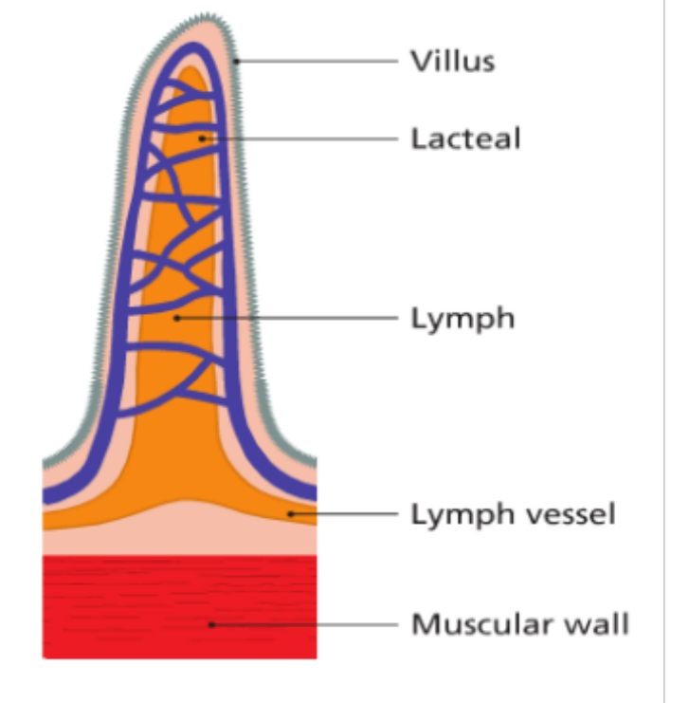

Large intestine
1.5 metres long and wider than small intestine. Functions – water reabsorption and elimination of faeces.
Caecum - ends in appendix. Both are vestigial (lost their former use). May play a role in immunity.

Colon - reabsorbs water (& mineral salts) - prevents dehydration.
Diarrhoea occurs when unabsorbed material moves too quickly through colon (less water reabsorbed). Constipation = vice-versa. Occasionally bacteria enter the large intestine that inflame the lining and cause diarrhoea e.g. cholera, salmonellosis or E. coli 0157, that it is fatal. Usually, after a short time the normal bacteria (10 ¹⁴) compete with them and replace them, and the intestine ‘settles down’ again.
Rectum - stores semi-solid waste (undigested material)
Anus - waste passes out of body as faeces i.e. egestion.
Waste consists of undigested food, mucus, cells from intestinal lining, bacteria and bile pigments.

Appendicitis:
A bacterial inflammation of the appendix.
Symptoms:
Pain is felt at the navel, and then travels to the right, lower abdomen. Nausea, vomiting and thirst are also common. If the appendix bursts bacterial infection of the abdomen lining can result (peritonitis)
Treatment:
Surgical removal of appendix almost always. Alternatively rest, antibiotics and a liquid diet are given.

Benefits of symbiotic intestinal bacteria:
- make vitamins B & K
- Protect us against pathogenic bacteria that may colonise our large intestine
- May protect us against cancer, as some of the chemicals they produce inhibit the growth of tumour cells

Role of fibre in the diet
Fibre consists of cellulose from plant cell walls. Good sources e.g. cereal grains, vegetable and fruit.
Benefits:
- It stimulates peristalsis - helps to keep the contents of the gut moving. Fibre absorbs water and provides bulk which gives the muscles of the intestine something to push against. Helps prevent constipation. Fibre absorbs water and this keeps the faeces soft.
- It soaks up cholesterol and toxic chemicals which helps to reduce the risk of colon cancer, heart disease and diabetes.
- May help prevent over-eating. Eating fibre-rich foods e.g. wholegrain bread and cereals often makes you feel full.
- Fibre encourages the growth of symbiotic mutualistic intestinal bacteria.

LIVER
Keeps internal fluids constant (homeostasis) by regulating the composition & temp. of the blood flowing through it.
Liver has 2 supplies of blood - hepatic portal vein brings monosaccharides and amino acids from intestine and hepatic artery brings oxygen and lipids from the aorta.
Hepatic vein brings blood from liver to inferior vena cava.
Functions:
- Produces bile
- Makes sodium hydrogen carbonate to neutralise acid
- Storage of fat-soluble vitamins A, D, E K, glycogen and minerals - iron is released from the breakdown of old red blood cells by the liver and spleen. Iron is stored before being recycled to make new red blood cells in the bone marrow.
- Detoxification of poisonous substances e.g. drugs & alcohol.
- Produces heat to warm the blood and body.
- Formation of cholesterol
  - Cholesterol is a lipid-like substance, needed in cell membranes and to make many hormones.
- Deamination - excess amino acids cannot be stored in body & are therefore broken down to form urea.
- Makes blood proteins e.g. fibrinogen used in blood clotting.

Balanced diet:
A balanced diet is one that contains seven components (carbohydrates, lipids, proteins, vitamins, minerals, water and fibre) in the correct amounts.

Variety
Obtain nutrients from a variety of food types. Note processed foods can be deficient. Vegetarian diets – need to get the full supply of nutrients, especially essential amino acids from various sources. Plants may be low in iron and lack a vitamin needed for red blood cell formation (30% vegetarians = anaemic)

Everything in moderation
A good diet is where a person is healthy, energetic, growing normally and body weight/percentage fat is normal (25% for females and 15% for males)
BMI (body mass index) can also be used as a health guide.
BMI = body weight (kg)/ height²(m²)
BMI 30 = obese, 25-30 = overweight, 20-25 = normal, < 20 = underweight, <17.5 = anorexic.
Life expectancy is due to decrease due to rise in obesity in young people. Obesity can lead to heart disease, middle-age diabetes, high blood pressure and stroke.

Food pyramid

A balanced diet depends on a number of factors including age, gender, activity and health.
- Age – rapidly growing teenagers need the most food.
- Gender – males tend to need more food than females.
- Physical activity – the higher the level of activity the greater the need for more carbos – energy, protein – repair ‘broken’ muscle and minerals e.g. sodium, lost in sweat.
RDA for 16 year old boys = 12600 kJ and for girls 9600 kJ
Carbohydrate/Protein = 17kJ per gramme
Fat = 38 kJ/g

Eating disorders include anorexia nervosa and bulimia nervosa.
Anorexia nervosa:
Causes unknown but often include:
- Family conflicts
- Fears of ‘growing up’
- Sexual abuse
Symptoms:
- severe weight loss
- amenorrhoea (no periods)
- low blood pressure
- osteoporosis
- injury from loss of body fat.
- damage to heart muscle.
- a fear of being fat (although the person may be very thin)
- an overinterest in food and weight.
Treatment:
- a controlled, healthy eating pattern
- weight gain
- counselling or therapy
- small, high-energy meals.
The person affected, usually female, age 12-18, and coming from middle-class backgrounds, has an excessive desire to be thin and to control their weight and shape. Anorexia can be fatal. 1-2% female students (second/third level) are anorexic. 10 times more common in females.

Bulimia involves binge eating, self-induced vomiting, craving for food, and periods of binge eating and starvation. Bulimia is easier to disguise than anorexia.
Causes – see above
Symptoms:
- acute stomach distension/Irregular period
- erosion of teeth by gastric juice
- constant weight fluctuations
- depression/low self-esteem
Treatment:
- restore normal healthy eating
- stop vomiting or other abusive behaviour
- counselling or therapy
- regular appointments with a doctor or dietician

Section A

Human Nutrition
2004 HL
1. (a) Name an autotrophic organism …………………………………………………………………..

SEC Sample Paper OL
1. Complete the following sentence by putting one word in the blank space.
(e) An animal that eats both plants and animals is called an ………………………………….…..

2006 OL
1. Use your knowledge of ecology to answer four parts of the following.
(a) An organism which makes its own food is called a(n) …………………………………………
(b) An organism that eats another organism is called a ……………………………………………....

Digestive System
2004 HL
6. Answer the following questions in relation to the human alimentary canal.
What is peristalsis? ………………………………………………………………….……………………
State one reason why a low pH is important in the stomach ……………………………………………..
……………………………………………………………………………………………………………..
Why is fibre important? …………………………………………………………………………..………
……………………………………………………………………………………………………………..
Name an enzyme that is involved in the digestion of fat …………………………………………………
What are the products of fat digestion? …………………………………………………………………..
What is the role of bile in fat digestion? ………………………………………………………………….
State a role of beneficial bacteria in the alimentary canal ……………………………………………….
…………………………………………………………………………………………………………….

2005 HL
3. Indicate whether the following are true (T) or false (F) by drawing a circle around T or F.
(a) Urea is formed in the kidneys.
2005 HL
6. The diagram shows part of a section of the human small intestine.

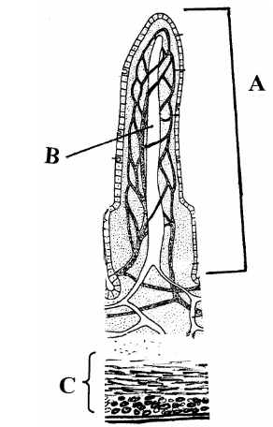

(a) Name A, B, C.
A ………………………………....
B …………….……………………
C ……………………………..…..
(b) State two ways in which A is adapted for the absorption of soluble foods.
1. ….………………………………………………………..………………………………….….
2. …………………………………………………………….…………………………………….
(c) Name a process by which soluble foods are absorbed into the blood from the small intestine.
.……………………………………………………….……………………………………………….
(d) What type of food is mainly absorbed into B?
………………………………………………………………….……………………………………..
2006 HL
1. (f) What are the final products of the digestion of a protein? …………………………………………….

2006 HL
3. The graph shows how the rate of reaction of a carbohydrate-digesting enzyme in the human alimentary canal varies with pH

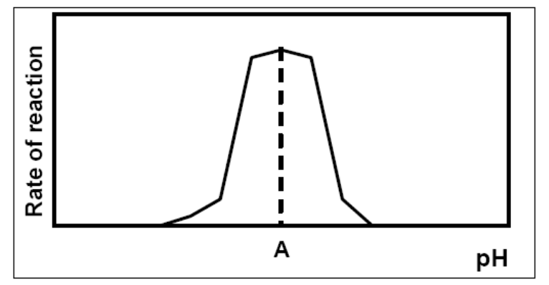

(a) Name a carbohydrate-digesting enzyme in the human alimentary canal ………………………
(b) Where in the alimentary canal does this enzyme act? ………………………………………….
(c) State the enzyme’s product (s) …………………………………………………………………
(d) What is the pH at A? …………..……………..
(e) A is said to be the enzyme’s ………………………….pH
(f) Suggest a temperature at which human enzymes work best……………………………………
(g) What term best describes the shape of an enzyme?.……………………………………………

2006 HL
5. Study the diagram and then answer the following questions.

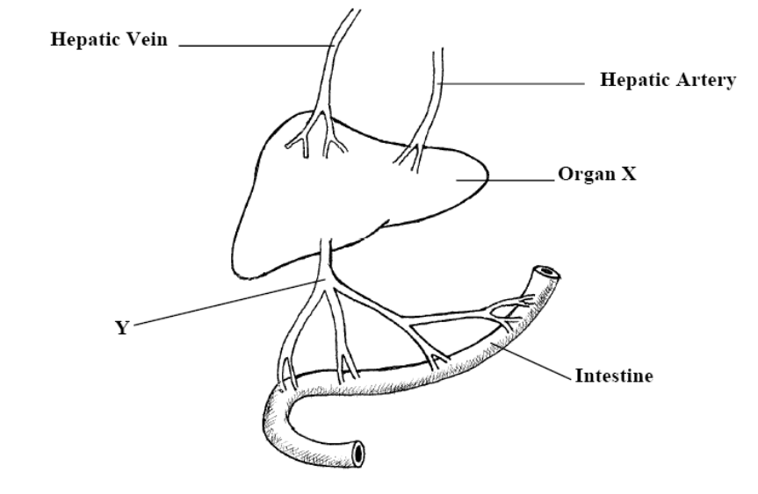

(d) State a role that organ X plays in the digestive process …………………………………………….
……………………………………………………………………………………………………….
2011 HL
5. (a) (i) What is meant by the term digestion? ______________________________________________
(ii) Why is digestion necessary? _____________________________________________________
(iii) Distinguish between mechanical and chemical digestion by writing a sentence about each.
_____________________________________________________________________________
_____________________________________________________________________________
(b) The diagram shows part of the human alimentary canal and associated structures.
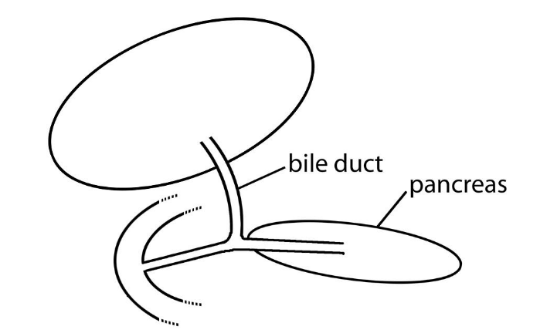
X
W
(i) What part of the alimentary canal is labelled W? _____________________________________
(ii) The bile duct is connected to X. Name X. ___________________________________________
(iii) From which part of the alimentary canal does food arrive into W? _______________________
(iv) State one digestive function of the pancreas. ________________________________________
SEC Sample Paper OL
1. Complete the following sentence by putting one word in the blank space.
(a) The hammer (malleus) is a very small bone located in the ……………………………………
(b) Bile is secreted by the …………………………………………………………………….……
(e) An animal that eats both plants and animals is called an ………………………………….…..

2004 OL
1. (a) The hepatic portal vein carries blood from the alimentary canal to the .………………………

Section B

Human Nutrition
2009 OL
9. (a) (i) What is meant by the term digestion?
_________________________________________________________________________

Digestive System
2005 HL
8. (b) (vi) What is a protease enzyme? ………………………………………………………………..

Section C

Human Nutrition.
2010 HL
15. Answer any two of (a), (b), (c). (30, 30)
(b) (i) Draw a labelled diagram to show the relationship between the liver, the small intestine and
the hepatic portal vein.
(ii) Name a substance transported to the liver by the blood in the hepatic portal vein.
(iii) Name the blood vessel that brings oxygenated blood to the liver.
(iv) Where in the human body is the liver located in relation to the stomach?
(v) Where is bile stored after it has been made in the liver?
(vi) Give one role that the bile salts play in the digestive process.
(vii) Give two further functions of the liver, other than the manufacture of bile.
2012 HL
12. (a) (i) From the following list, write into your answer book any term that describes the nutrition of a typical plant:
parasitic; heterotrophic; saprophytic; autotrophic
2006 OL
12. (c) (i) What is meant by absorption?

2007 OL
13. (b) (i) Distinguish between autotrophic and heterotrophic nutrition.

2007 OL
15. (c) (i) Copy the following passage into your answer book and fill in the blank spaces.
“The passage of the products of digestion from the intestine to the blood is called ………….

2010 OL
13. (c) The liver, the gall bladder and the pancreas all play a part in digestion. Digested food is
carried to the liver where it is processed. Undigested food enters the large intestine.
(i) State
1. One role of the pancreas in digestion.
2. One role of the gall bladder in digestion.
(ii) From what part of the digestive system does the digested food enter the blood?
(iii) Name the blood vessel that carries the digested food to the liver.
(iv) State two functions of the liver – other than the processing of digested food.
(v) The colon contains many symbiotic bacteria – mostly ‘good’ bacteria.
State two benefits we get from these bacteria. (24)

Digestive System
2008 HL
12. (a) (i) Distinguish between mechanical and chemical digestion.
(ii) Name a structure in the human digestive system, other than teeth, which is involved in mechanical digestion. (9)

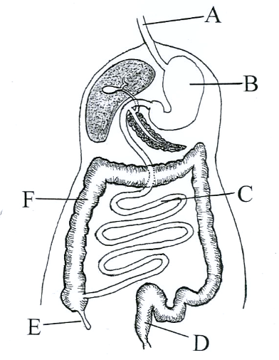
(b) The diagram shows the human digestive system.
(i) Name the parts A, B, C, D, E and F.
(ii) Describe two functions of bile in relation to digestion.
(iii) Answer the following in relation to a lipase:
1. Where is it secreted?
2. Where does it act?
3. What is the approximate pH at its site of action? (27)

(c) (i) What are symbiotic bacteria?
(ii) Give two activities of symbiotic bacteria in the human digestive system.
(iii) Name the part(s) of the digestive system in which the following are absorbed into the blood.
1. the products of digestion,
2. water.
(iv) Name a process involved in the passage of the products of digestion into the blood.
(v) Explain how the structure that you have named in (iii) 1. is adapted for the absorption of the products of digestion.
2010 HL
15. Answer any two of (a), (b), (c). (30, 30)
(b) (i) Draw a labelled diagram to show the relationship between the liver, the small intestine and
the hepatic portal vein.
(ii) Name a substance transported to the liver by the blood in the hepatic portal vein.
(iii) Name the blood vessel that brings oxygenated blood to the liver.
(iv) Where in the human body is the liver located in relation to the stomach?
(v) Where is bile stored after it has been made in the liver?
(vi) Give one role that the bile salts play in the digestive process.
(vii) Give two further functions of the liver, other than the manufacture of bile.

(c) Suggest a biological explanation for each of the following observations:

(iii) A person who has suffered from constipation may be advised to increase the amount
of wholegrain cereal in her/his diet.
2012 HL
15. Answer any two of (a), (b), (c). (30, 30)

(a) The diagram shows part of a transverse section through the small intestine.
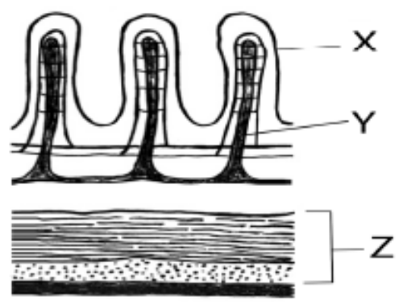
(i) Name structures X and Y.
(ii) What process results from the contraction of the two parts of tissue Z?
(iii) In your answer book, indicate which of the following most accurately represents the pH of
the contents of the small intestine.
Acidic. Neutral. Alkaline.
(iv) Name two glands that pass their secretions into the small intestine.
(v) 1. What are symbiotic bacteria?
2. Give two functions of symbiotic bacteria in the human alimentary canal.
(vi) Where in the human alimentary canal is most water absorbed?

2004 OL
10. (c) (iii) Proteins are digested to simpler substances. What are these simpler substances called?

2006 OL
12. (a) (i) Write the dental formula for an adult human.
(ii) Give a function of any one of the teeth indicated in the dental formula. (9)

(b) The diagram shows the human digestive system.
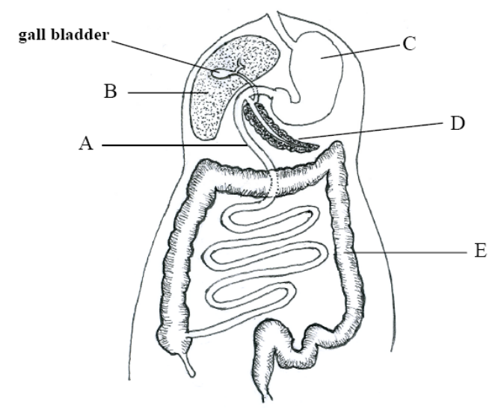
(i) Identify A, B, C, D and E in the diagram.
(ii) What is an amylase? Name a site of amylase action. What is the approximate pH value at this site?
(iii) Give one function of symbiotic bacteria in the human digestive system.
(iv) State a benefit of dietary fibre. (27)

(c) (i) What is meant by absorption?
(ii) Where in the digestive system are the products of digestion absorbed? State one way in which this part of the system is adapted for absorption.
(iii) Name the blood vessel that joins the part of the digestive system that you have named in (ii) to B in the diagram.
(iv) In which part of the digestive system is water absorbed? Give another function of this part of the digestive system.
2007 OL
15. (c) (i) Copy the following table into your answer book. Complete the table by inserting the correct
terms from the following list:

molar teeth, symbiotic bacteria, peristalsis, bile salts, lipase, stomach

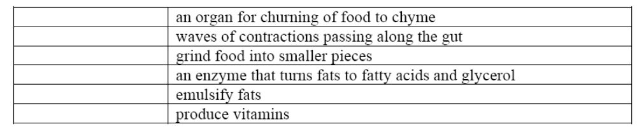

(ii) Copy the following passage into your answer book and fill in the blank spaces.

“The passage of the products of digestion from the intestine to the blood is called …………. Folds in the lining of the intestine, called …………., increase the surface area for this passage. Amino acids from the digestion of ………….. and monosaccharides from the digestion of ……….. enter the blood in this process.”
2008 OL
13. (a) Bile is involved in digestion in the human body.
(i) 1. Where is bile produced?
2. Where is bile stored?
(ii) Where does bile act in the alimentary canal? (9)
(b) The diagram shows the digestive system of the human.
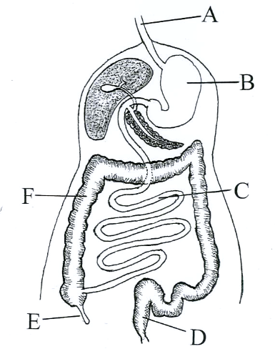
(i) Name the parts labelled A, B, C, D, E and F.
(ii) What is the role of peristalsis in the digestive system?
(iii) Where do the products of digestion enter the blood?
(iv) How do these products of digestion pass into the blood? (27)
(c) (i) For each of the parts labelled B and C in the diagram above, state whether the contents are
acidic, neutral or alkaline.
(ii) Amylase is an enzyme that is found in saliva. State the substrate and the product of this enzyme.
(iii) State two functions of symbiotic bacteria in the alimentary canal.
(iv) What is meant by egestion? From which labelled part of the diagram does egestion occur?
(24)
2010 OL
13. (a) (i) What is meant by a ‘balanced’ diet?
(ii) Distinguish between autotrophic nutrition and heterotrophic nutrition. (9)
(b) (i) Explain the word digestion.
(ii) Give one role for each of the following types of teeth:
1. Incisors
2. Molars.
(iii) Peristalsis begins when food enters the oesophagus.
What is meant by peristalsis?
(iv) Describe the following changes that happen to food in the stomach:
1. Mechanical changes
2. Chemical changes.
(v) What is the pH of the stomach contents?
(vi) Where does the partially digested food go when it leaves the stomach? (27)
(c) The liver, the gall bladder and the pancreas all play a part in digestion. Digested food is
carried to the liver where it is processed. Undigested food enters the large intestine.
(i) State
1. One role of the pancreas in digestion.
2. One role of the gall bladder in digestion.
(ii) From what part of the digestive system does the digested food enter the blood?
(iii) Name the blood vessel that carries the digested food to the liver.
(iv) State two functions of the liver – other than the processing of digested food.
(v) The colon contains many symbiotic bacteria – mostly ‘good’ bacteria.
State two benefits we get from these bacteria. (24)
2012 OL
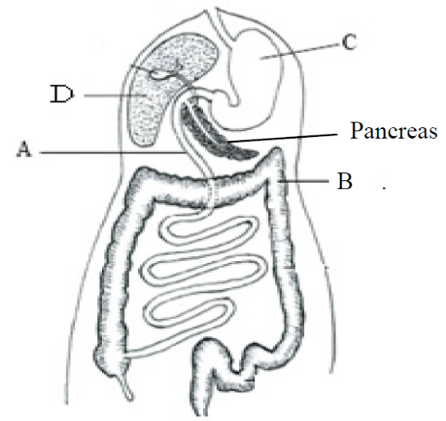
15. Answer any two of the parts (a), (b), (c). (30, 30)

(c) The diagram shows the human digestive system.
(i) Name the parts labelled A, B and C.
(ii) Explain the term digestion?
(iii) Name one human tooth type and give its function.
(iv) Part C secretes hydrochloric acid onto the ingested food.
Give one function of this acid.
(v) Give one digestive function of part D.
(vi) Give one digestive function and one non-digestive
function of the pancreas.

Section A

Human Nutrition

2004 HL
1. | any five |  | 2(7)+3(2)
 | (a) | Any named plant or named photosynthetic bacteria or cyanobacteria [allow grass,seaweed, fern, moss]

2004 OL Sample
1. |  |  |  | 4(5)
 | (e) |  | Omnivore

2006 OL
1. | any four |  | 2(7)+2(3)
 | (a) | Autotroph or producer [allow (named) plant)]

Digestive System

2004 HL
6. |  |  | 2(5)+5(2)
 |  | Muscular activity or description e.g. contractions to move food [allow ‘movement of food’]
 |  | Kills germs or optimal pH for enzymes or hydrolysis of starch or other correct reason
 |  | Peristalsis or explained (e.g. bulk for movement) [accept reference to constipation or bowel cancer]
 |  | Lipase
 |  | Fatty acids or glycerol
 |  | Emulsification (must imply smaller globules produced) or pH effect or explained
 |  | Production of vitamins or inhibition of pathogens or (aids) digestion or example

2005 HL
3. |  |  | 5(1)+5(3)
 | (a) | False

2005 HL
6. |  |  | 5(2)+2(5)
 | (a) | A = villus  B = lacteal or lymph vessel  C = muscle or wall
 | (b) | Large surface area / rich blood supply / microvilli / thin-walled / lacteal | any two
 | (c) | Diffusion (passive transport)
 | (d) | Fats / fatty acids /glycerol / lipids | any one

2006 HL
3. |  |  | 6(3)+2
 | (a) | amylase [accept any correct enzyme]
 | (b) | mouth / small intestine or named part
 | (c) | matching carbohydrate product
 | (d) | pH 7 - 9
 | (e) | optimum
 | (f) | 35 ⁰C - 40 ⁰C
 | (g) | folded or described

2006 HL
5. |  |  | 6(3)+2
 | (a) | X: liver  Y: (hepatic) portal vein or portal system
 | (b) | Arrow 1 –  Arrow 2 –  Arrow 3 –
 | (c) | upper abdomen or under diaphragm or correctly related to stomach
 | (d) | (produces) bile or emulsification or (produces) NaHCO₃ or neutralizes acid

2011 HL
5. |  |  | 6 (3) + 2
 | (a) | (i) | The breakdown of food
 |  | (ii) | For solubility or for absorption or for transport
 |  | (iii) | Mechanical: physical or grinding or cutting or churning or chewing or emulsifying  Chemical: (action of) enzyme or named enzyme or (action of) acid or named acid
 | (b) | (i) | Duodenum or small intestine
 |  | (ii) | Gall bladder or liver
 |  | (iii) | Stomach
 |  | (iv) | (Produces) enzymes or named enzyme or neutralises (chyme)
SEC Sample Paper OL
1.
 | (a) |  | Ear
 | (b) |  | Liver
 | (c) |  | Stoma (Stomata)
 | (d) |  | Ligaments
 | (e) |  | Omnivore

2004 OL
1. | any four |  | 2(8)+2(2)
 | (a) | liver
 | (b) | muscle
 | (c) | light or source
 | (d) | endocrine or ductless glands or name of gland
 | (e) | stomata or dermal tissue or named tissue

Section B

2009 OL
9. |  |  |  | 5 + 1
 | (a) | (i) | Breaking down food

2005 HL
8 | (b) | (vi) | Breaks down (acts on) protein | 3

Section C

Human Nutrition.

2010 HL
15. | (b) | (i) | Diagram (liver, connection, gut)  Labels (liver, intestine and portal vein) | 3, 0  3(2)
 |  | (ii) | Named food or CO₂ | 3
 |  | (iii) | *Hepatic artery | 3
 |  | (iv) | Above or to the right or behind | 3
 |  | (v) | *Gall bladder | 3
 |  | (vi) | Emulsify fats (or explained) or neutralise (or comment on pH) | 3
 |  | (vii) | Storage of (fat-soluble) vitamins (or glycogen or named mineral) / deamination / heat generation / detoxification / plasma protein production / cholesterol production  Any two | 2(3)

2012 HL Q12
12. | (a) | (i) | *Autotrophic | 3
 |  | (ii) | (A =) *mitochondrion  (B =) *chloroplast | 3  3

Digestive System

2008 HL Q12
12. | (a) | (i) | mechanical:  physical or grinding or cutting or churning or chewing or emulsifying  chemical:  enzyme or acidic action or molecular breakdown | 3  3
 |  | (ii) | tongue or oesophagus or stomach or small intestine or named part of small intestine | 3
 | (b) | (i) | A = oesophagus B = stomach C = small intestine or ileum  D = rectum E = appendix F = large intestine or colon | 6(2)
 |  | (ii) | emulsification or explained  neutralisation or raises pH or makes alkaline | 3  3
 |  | (iii) | 1. pancreas [allow duodenum]  2. duodenum or small intestine or ileum  3. 7 - 9 inclusive | 3  3  3
 | (c) | (i) | (bacteria that) live in (or on) another organism involving benefit | 6
 |  | (ii) | digestion / production of vitamins / benefit immune system / compete with other micro-organisms [allow one reference to harmful activity] | 2(3)
 |  | (iii) | 1. ileum or villi [allow duodenum or small intestine]  2. Colon [allow any named part from stomach onwards] | 3  3
 |  | (iv) | diffusion or passive transport | 3
 |  | (v) | large surface area (folding) or good blood supply or lymph supply or  (lining) one cell thick or long or villi or microvilli | 3

2010 HL Q15(b)
15. | (b) | (i) | Diagram (liver, connection, gut)  Labels (liver, intestine and portal vein) | 3, 0  3(2)
 |  | (ii) | Named food or CO₂ | 3
 |  | (iii) | *Hepatic artery | 3
 |  | (iv) | Above or to the right or behind | 3
 |  | (v) | *Gall bladder | 3
 |  | (vi) | Emulsify fats (or explained) or neutralise (or comment on pH) | 3
 |  | (vii) | Storage of (fat-soluble) vitamins (or glycogen or named mineral) / deamination / heat generation / detoxification / plasma protein production / cholesterol production  Any two | 2(3)

2010 HL
15. | (b) | (i) | Diagram (liver, connection, gut)  Labels (liver, intestine and portal vein) | 3, 0  3(2)
 |  | (ii) | Named food or CO₂ | 3
 |  | (iii) | *Hepatic artery | 3
 |  | (iv) | Above or to the right or behind | 3
 |  | (v) | *Gall bladder | 3
 |  | (vi) | Emulsify fats (or explained) or neutralise (or comment on pH) | 3
 |  | (vii) | Storage of (fat-soluble) vitamins (or glycogen or named mineral) / deamination / heat generation / detoxification / plasma protein production / cholesterol production  Any two | 2(3)

2010 HL
15. | (c) | (iii) | Adds fibre / fibre absorbs water / peristalsis encouraged / faster digestive transit  Any two | 2(3)

2012 HL Q15(a)
15. | (a) | (i) | (X =) *Villus  (Y =) *Lacteal |  | 3  3
 |  | (ii) | *Peristalsis |  | 3
 |  | (iii) | *Alkaline |  | 3
 |  | (iv) | *Pancreas  *Liver |  | 3  3
 |  | (v) | 1.  2. | (Bacteria) living on or in another organism involving benefit  Vitamin production / compete with pathogens / reference to digestion / inhibits cancer cells | 3  2(3)
 |  | (vi) | *Colon or *large intestine |  | 3

2006 OL Q12
12. | (a) | (i) | i 2/2 c 1/1 pm 2/2 m 3/3  2 1 2 3 | 2
 |  | (ii) | Tooth type & function | 6+1
 | (b) |  |  | 8(3)+3(1)
 |  | (i) | A = duodenum (small intestine) B = liver C = stomach  D = pancreas E = colon(large intestine
 |  | (ii) | Enzyme or breaks down / starch  mouth or duodenum or ileum or small intestine  Anything between pH 7 and pH 9
 |  | (iii) | Digestion or produce vitamins or kills harmful bacteria
 |  | (iv) | Peristalsis or prevents constipation or prevents (colon) cancer or forms faeces
 | (c) | (i) | Movement (passage) / across membrane / into blood or lymph | 3+1
 |  | (ii) | (Small) intestine or ileum or villus  long/villi/ microvillus/ capillary network/lacteals or lymph vessels  any one | 6  1
 |  | (iii) | (hepatic) portal vein | 1
 |  | (iv) | Colon or rectum or stomach or duodenum or ileum  stores faeces or expels faeces or digestion or digestion or digestion  (Allow Intestine) | 6  6

2007 OL Q13
13.
 | (a) |  | (i) | capsule or slime layer or mucilage  protection |  | 3  3
 |  |  | (ii) | flagellum or plasmid |  | 3
 | (b) |  | (i) | autotrophic nutrition – makes own food  heterotrophic – uses food already made (made by other organisms) |  | 3  3
 |  |  | (ii) | feed on dead matter |  | 3
 |  |  | (iii) | decompose dead organisms or recycle nutrients |  | 3
 |  |  | (iv) | obtain energy (make food) from chemical reactions |  | 3

2007 OL Q15(c)
(i)
  Stomach | an organ for churning of food to chime
  Peristalsis | waves of contractions passing along the gut
  Molar teeth | grind food into smaller pieces
  Lipase | an enzyme that turns fats to fatty acids and glycerol
  Bile salts | emulsify fats
  Symbiotic bacteria | produce vitamins
(ii) |  | absorption/ villi/ protein (or polypeptides or peptides or name protein or source of protein)/ carbohydrates (polysaccharides or disaccharides or sugar or named carbohydrate or source of carbohydrate)

2010 OL Q13
13. | (a) | (i) | (One which contains) all the food types/in correct or suitable or  optimum proportions (Two points) | 7+2(1)
 |  | (ii) | Autotrophic nutrition: Food synthesised from simple molecules or produces own food (Either point answered)  Heterotrohic nutrition: Already synthesised food consumed from other organisms or food from other sources
 | (b) | (i) | The breaking down of food | 3(5)+6(2)
 |  | (ii) | 1. Cutting (food)  2. Chewing/grinding (food)
 |  | (iii) | (Muscular) contractions/in the walls of the alimentary canal/to move food (Two points)
 |  | (iv) | 1. Churned  2. pH changes or broken down by acid or broken down by enzymes or proteins → peptides
 |  | (v) | 0 − 3
 |  | (vi) | Duodenum or small intestine
 | (c) | (i) | 1. Pancreas: Makes enzymes or makes neutralising secretion or makes NaHCO₃  2. Gall bladder: Stores bile or releases bile | 2(6)+6(2)

2010 OL Q13
13. | (a) | (i) | (One which contains) all the food types/in correct or suitable or  optimum proportions (Two points) | 7+2(1)
 |  | (ii) | Autotrophic nutrition: Food synthesised from simple molecules or produces own food (Either point answered)  Heterotrohic nutrition: Already synthesised food consumed from other organisms or food from other sources
 | (b) | (i) | The breaking down of food | 3(5)+6(2)
 |  | (ii) | 1. Cutting (food)  2. Chewing/grinding (food)
 |  | (iii) | (Muscular) contractions/in the walls of the alimentary canal/to move food (Two points)
 |  | (iv) | 1. Churned  2. pH changes or broken down by acid or broken down by enzymes or proteins → peptides
 |  | (v) | 0 − 3
 |  | (vi) | Duodenum or small intestine
 | (c) | (i) | 1. Pancreas: Makes enzymes or makes neutralising secretion or makes NaHCO₃  2. Gall bladder: Stores bile or releases bile | 2(6)+6(2)

